Speech Processing Lab Assignment – 1

Name: Paruchuri Sai RegNo: BL.EN.U4AID23063

Basic Signal Operations on a Speech File

Dataset Description: The speech file is taken from LJ Speech Dataset from Kaggle website which contains short audio clips of speakers reading passages from books. The speech has 9 seconds duration.

Objective: The objective of this assignment is to understand how to import a speech file, extract basic data about the file like its duration, sampling rate and to perform operations like normalization, slicing, Amplification, de-amplification, Up-sampling and Down-sampling of the audio signals.

Code and Output:

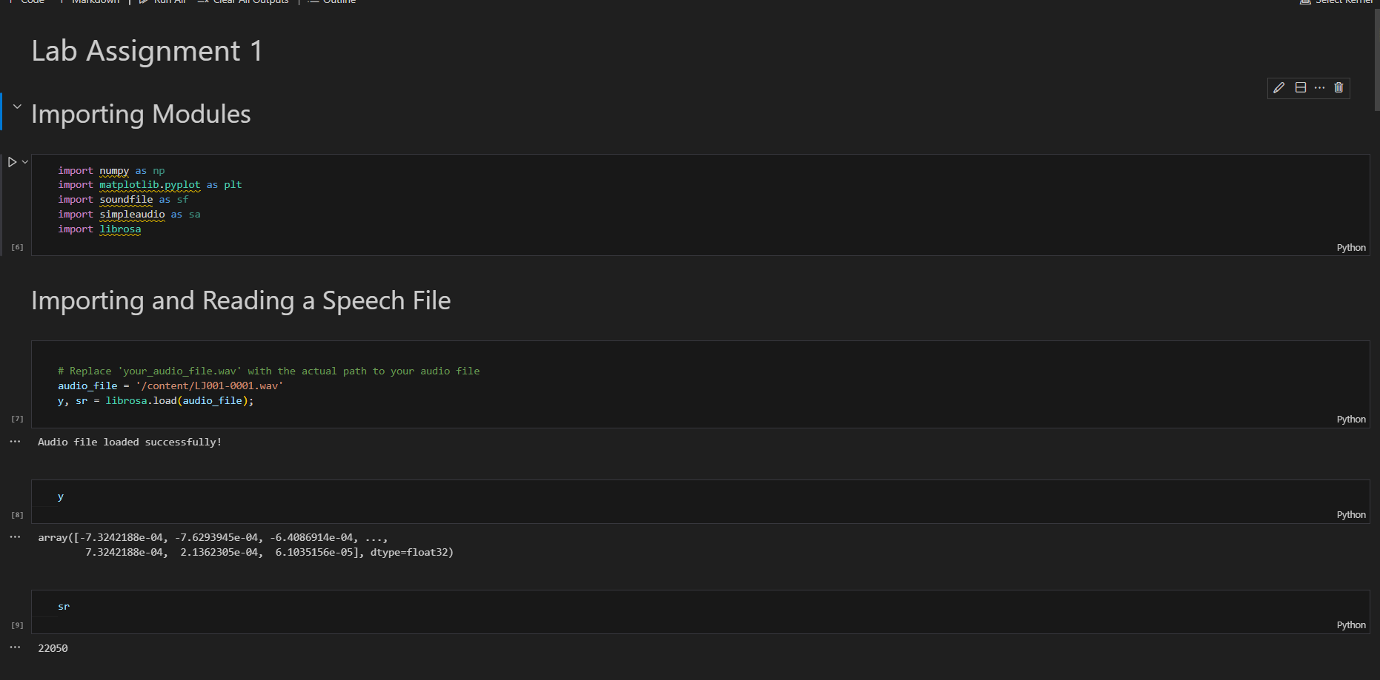

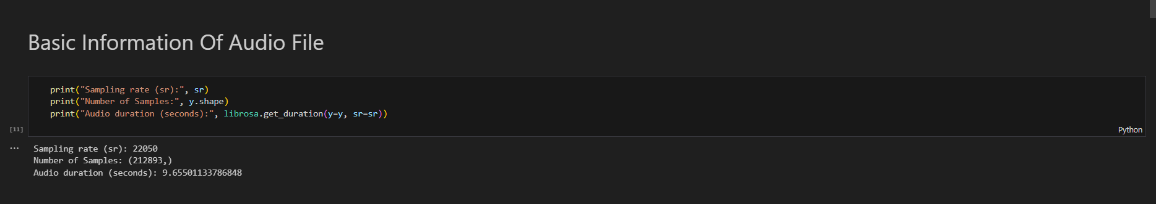

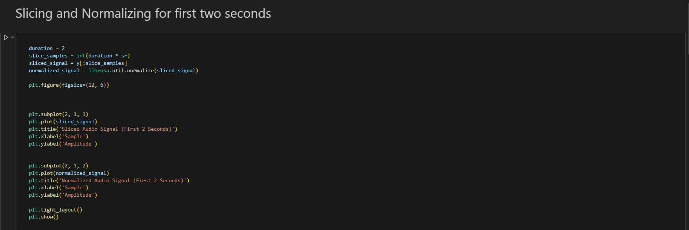

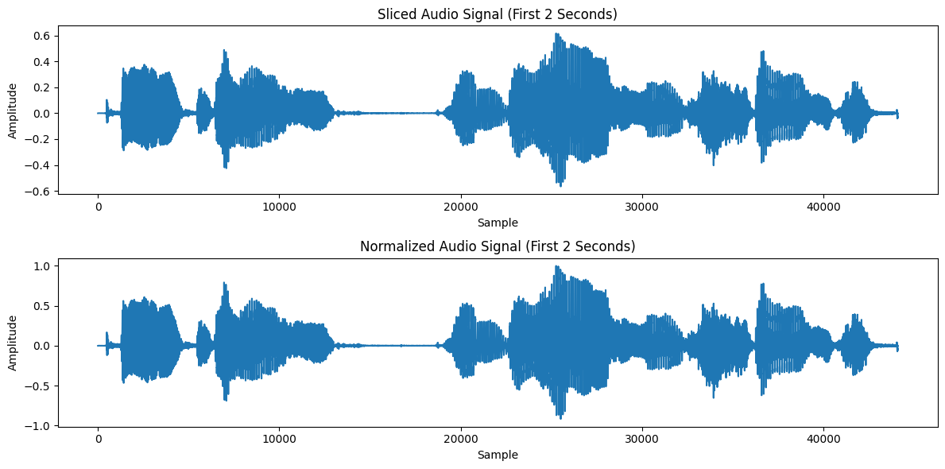

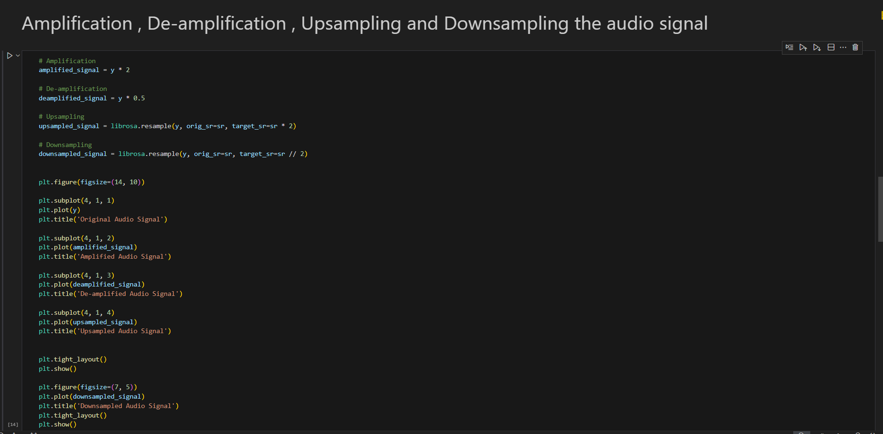

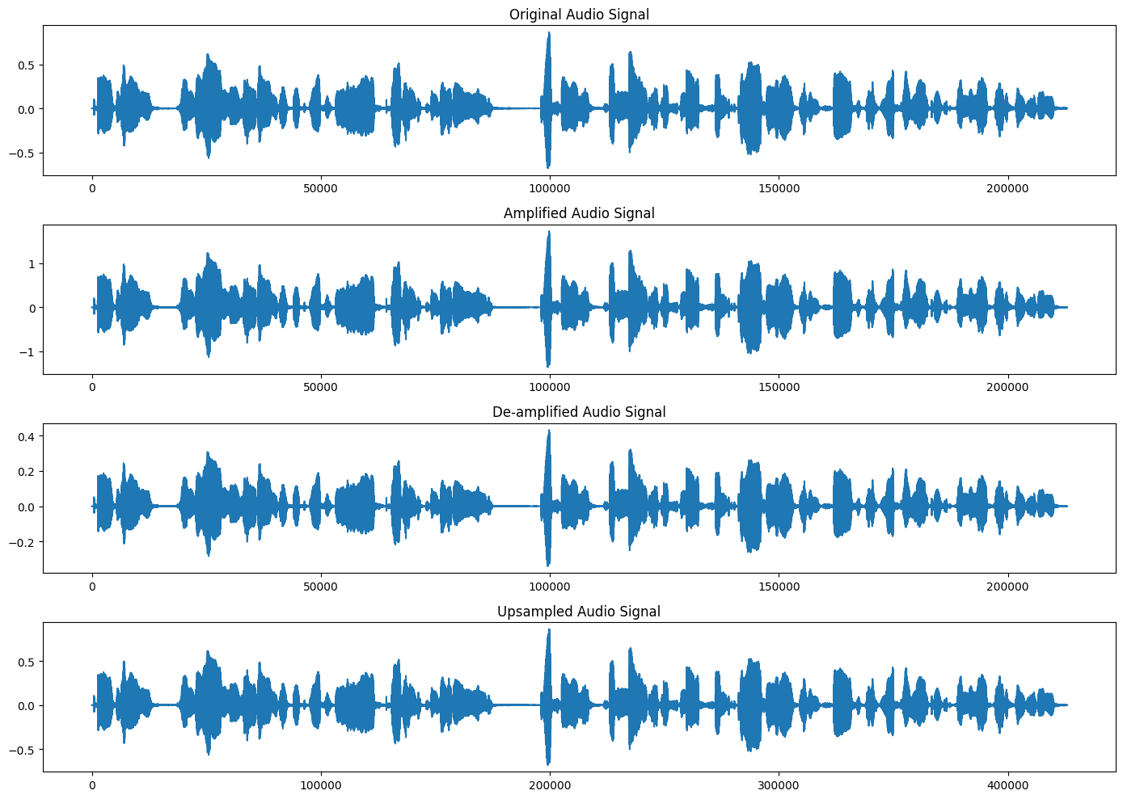

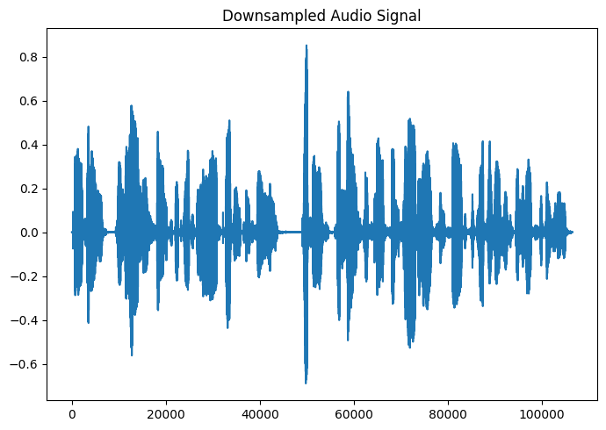

Conclusion:

We have seen in this assignment how to import and read the speech file and how to display its basic information and slicing the audio files, normalizing the audio files , how to plot these audio signals , amplifying , de-amplifying , Up-sampling , Down-sampling the audio signal.